Apartment Finder Application User Guide

Program by Tianyi Wang, Yijie Yan, Haokun Lin

**Table of Contents**

Introduction ……………………………………………………………………………………………………. Pg.3

Login…………………………………………………………………………………………………………………. Pg.4

New User Registration………………………………………………………………………………………. Pg.5

Home Page………………………………………………………………………………………………………. Pg.6

Search result……………………………………………………………………………………………………. Pg.7

View and Apply………………………………………………………………………………………………… Pg.8

Customer Transaction………………………………………………………………………………………. Pg.9

Customer Transaction Confirmation…………………………………………………………………. Pg.10

Manage Application…………………………………………………………………………………………. Pg.11

Cancel Application……………………………………………………………………………………………. Pg.12

Cancellation Confirmation………………………………………………………………………………… Pg.13

**Introduction**

Apartment Finder System is providing people a system for finding apartment. People can find apartment and apply for it in this system. In addition, people can manage applications in the system. This report is telling people how to use this system.

**Login**

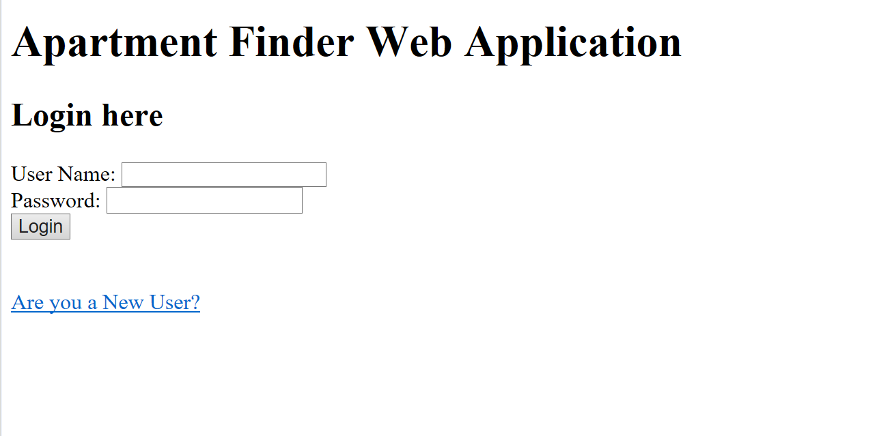

Users who have previously registered for the Apartment Finder Web Application must login by:

* Entering their User Name.
* Entering their Password.
* Selecting Login to advance to the next screen and begin using the application

**Site Registration**

Users who have not previously registered for the Apartment finder Web Application must select “Are you a New User? ” to access the “Register” page.

**Register**

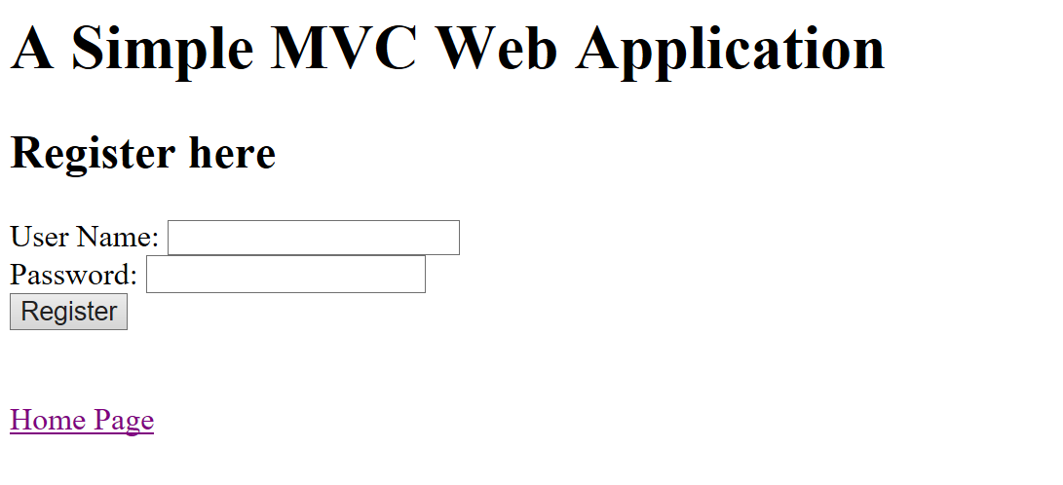

Users will be asked to enter the following information

**User Name**

Enter the user name for login the system. Every user is required to select a unique user name and password.

**Password**

Enter the password for user to login the system.

**Home Page**

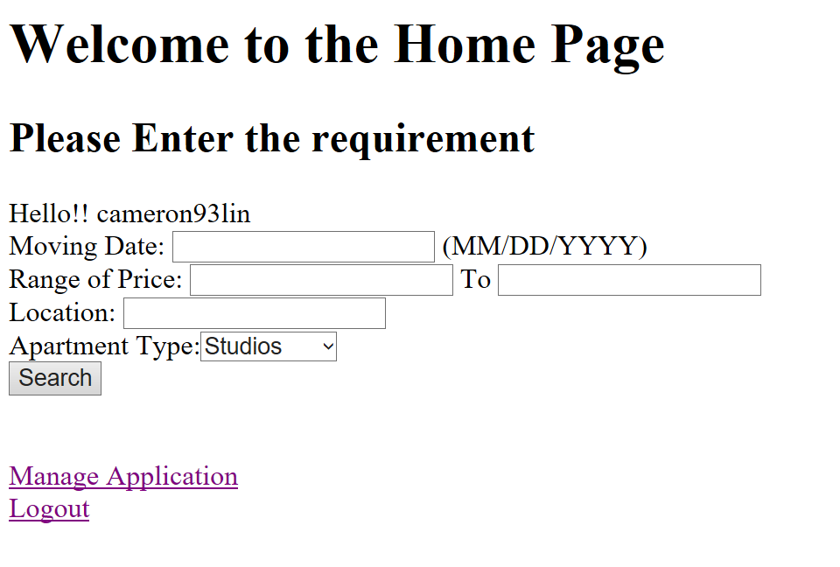

Users will be asked to enter the following information to search apartments.

**Moving Date**

Enter the date users want to move in.

**Range of Price**

Enter the range of price from lower to higher

**Location**

Enter the Location users want to search

**Apartment Type**

Select the Apartment Type users want to search

**Search**

Select “Search” to start searching

**Manage Applications**

Select “Manage Applications” to start manage applications

**Logout**

Click to logout the system and back to the Login page

**Search Result**

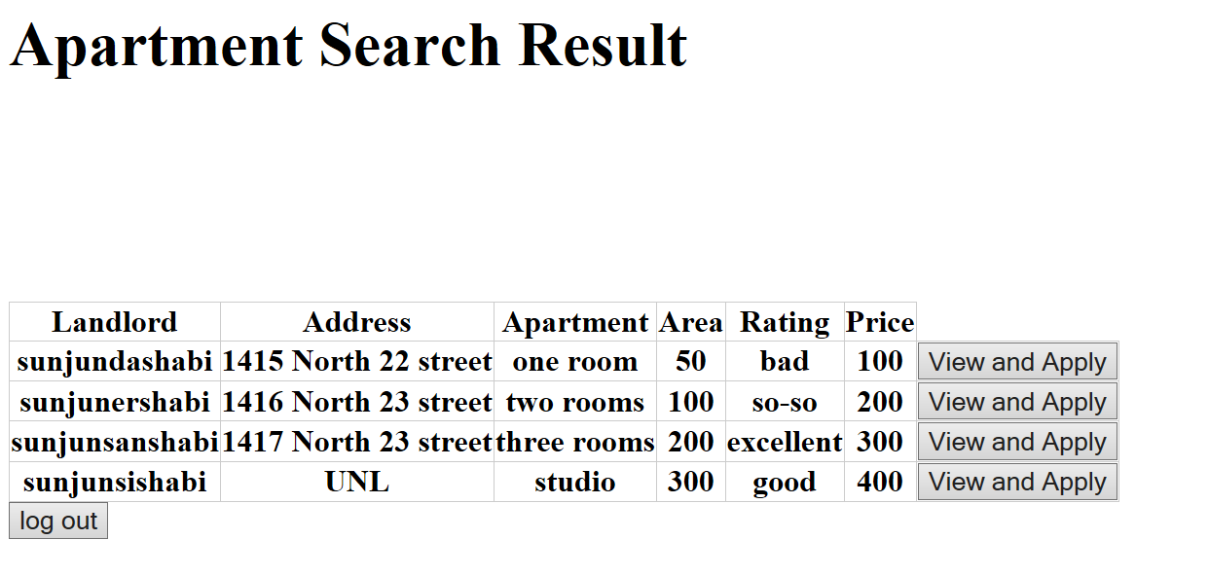

**View and Apply**

Click to view the detail of this apartment and apply for it

**Manage Applications**

Click to Manage Applications page

**Logout**

Click to logout the system and back to the Login page

**View and Apply**

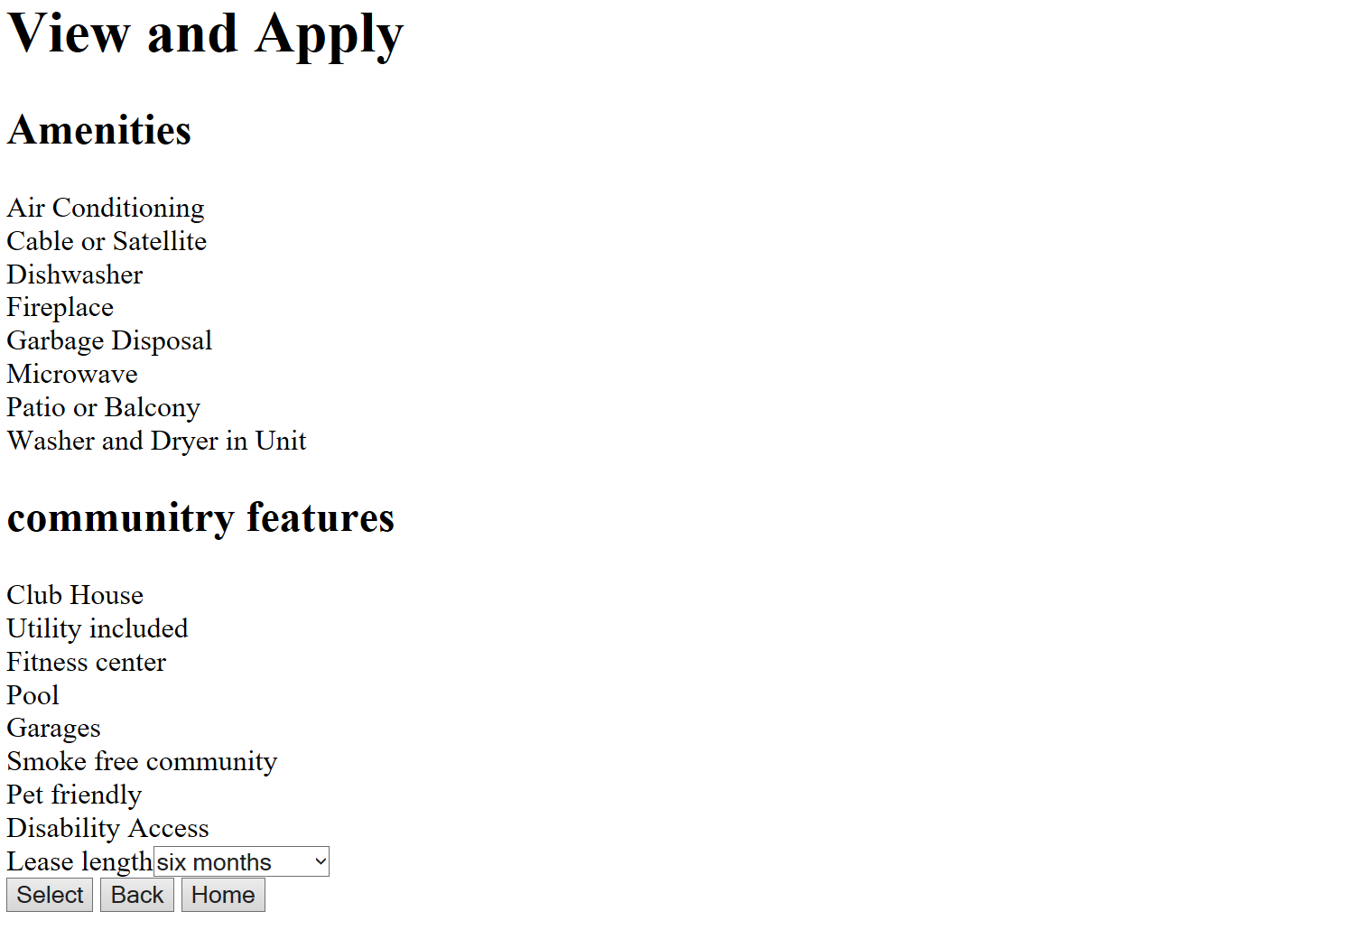

**Lease Length**

Select the length of the lease

**Select**

Click to begin application

**Back**

Click to back to the search result page

**Home**

Click to back to the home page

**Logout**

Click to logout the system and back to the Login page

**Customer Transaction**

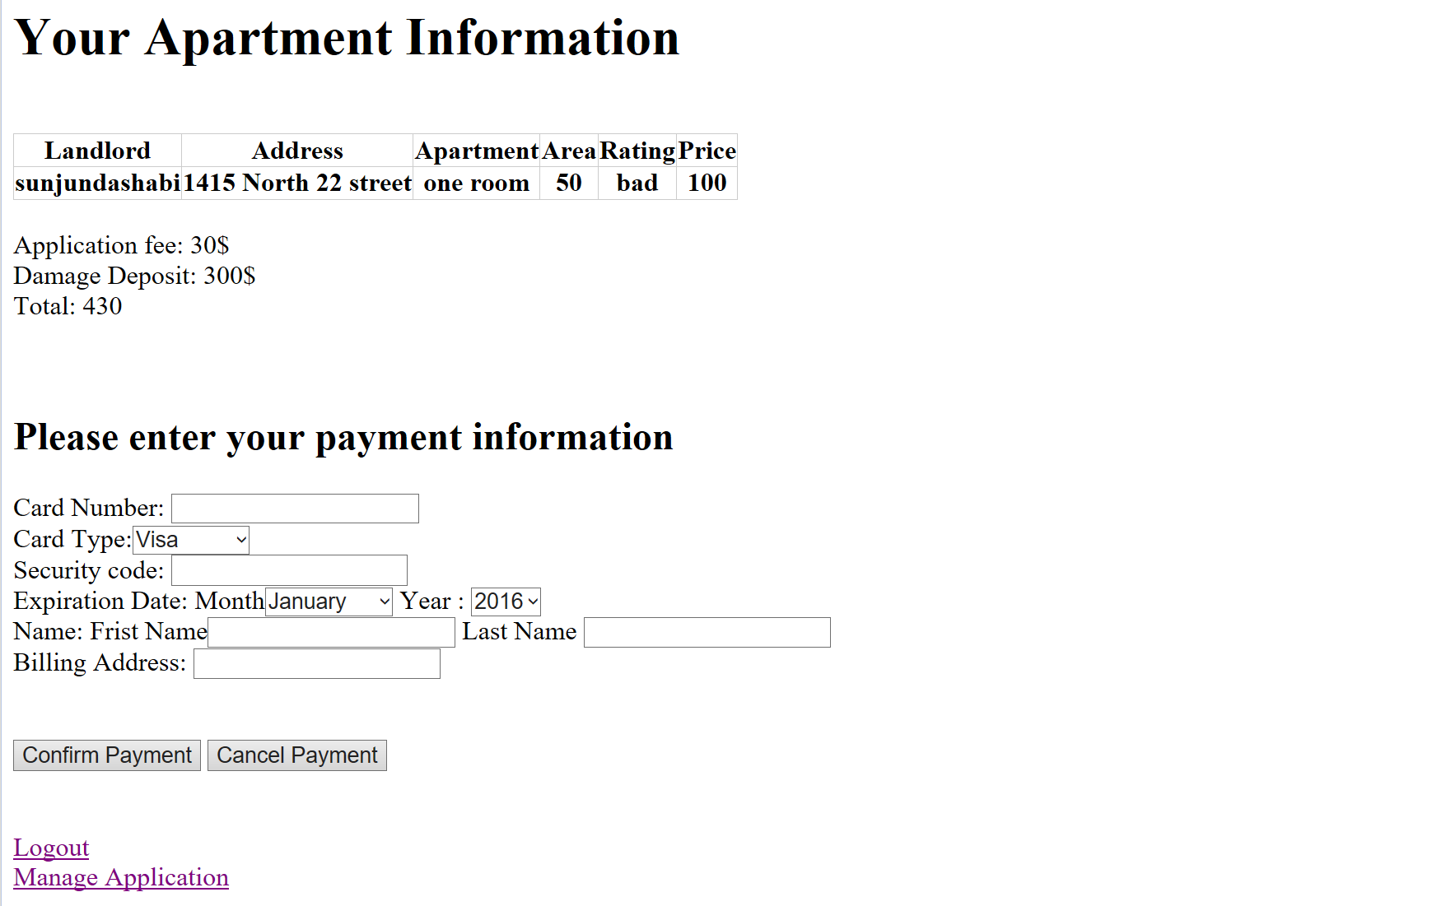

Users will be asked to enter the following information

**Card Number**

Enter the number of the card that use to pay the application fee

**Card Type**

Select the Card Type

**Security Code**

Enter the 3-digits security code located on the back of the card.

**Expiration Date**

Select the Expiration Date of the card

**Name-First and Last Name**

Enter the name list on your card

**Billing Address**

Enter the billing address of your card

**Confirm Payment**

Click to Customer Transaction Confirmation page

**Cancel Payment**

Click to back to Search Result page

**Manage Application**

Click to Manage Application page

**Logout**

Click to logout the system and back to the Login page

**Customer Transaction Confirmation**

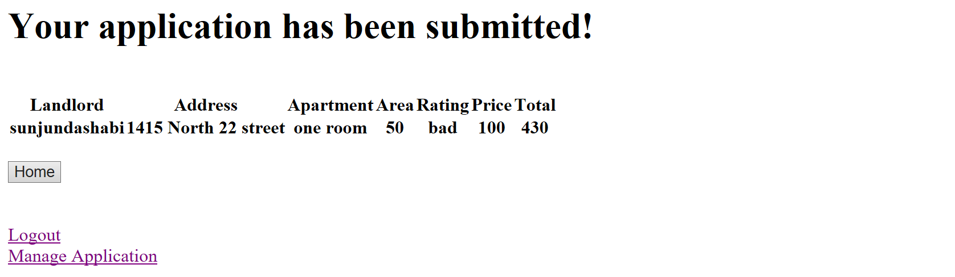

This page is showing that the transaction has been complete.

**Home**

Click to back to Home page

**Logout**

Click to logout the system and back to the Login page

**Manage Application**

Click to Manage Application page

**Manage Application**

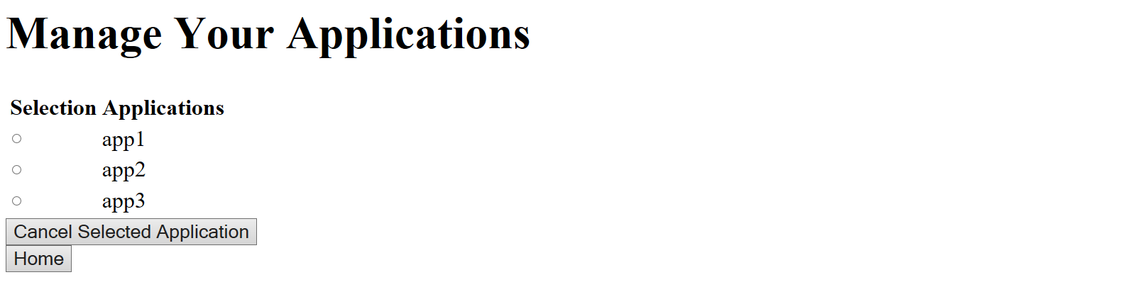

This page shows the Application that the users make and users will be able to cancel selected application

Users will be asked to select the application that they want to cancel

**Cancel Selected Application**

Click to Cancel Application page

**Home**

Click to back to Home page

**Cancel Application**

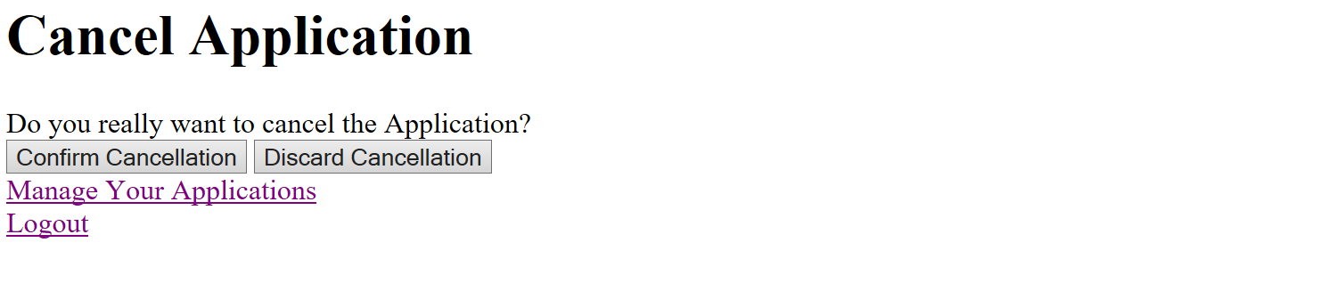

**Confirm Cancellation**

Click to Cancellation Confirm page

**Discard Cancellation**

Click to back to the home page

**Manage Application**

Click to back to Manage Application page

**Logout**

Click to logout the system and back to the Login page

**Cancellation Confirmation**

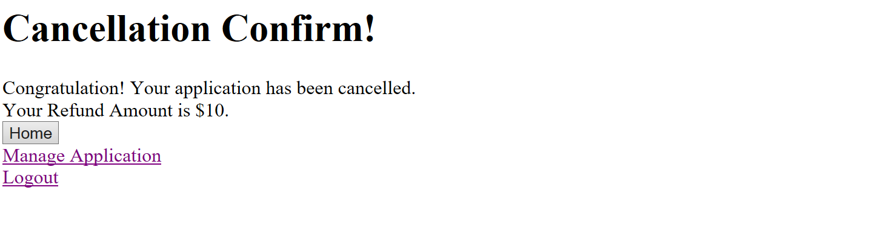

**Home**

Click to back to Home page

**Manage Application**

Click to back to Manage Application page

**Logout**

Click to logout the system and back to the Login page